**Schematic View:**

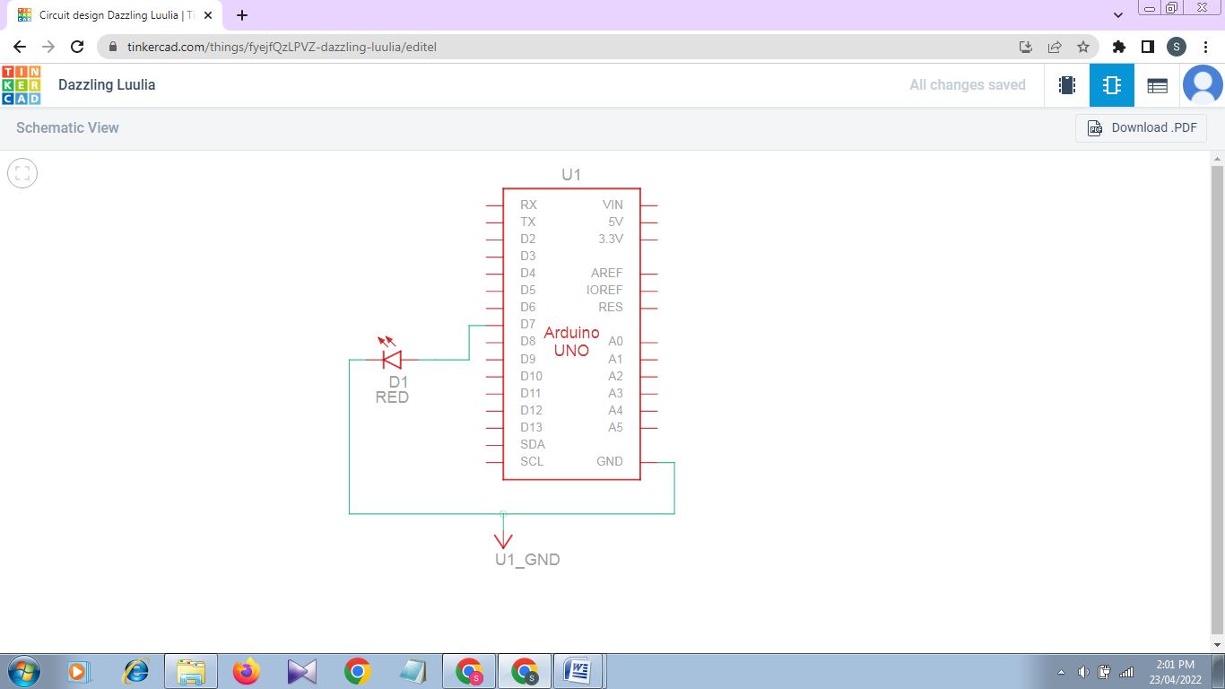

**Circuit View:**

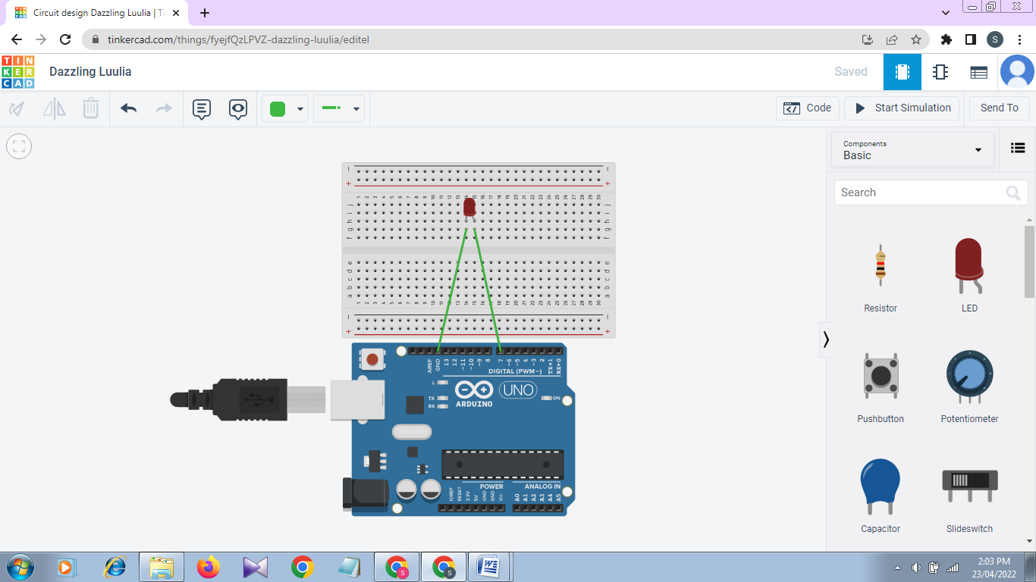

**Code:**

int red=7;

void setup()

{

pinMode(red, OUTPUT);

}

void loop()

{

digitalWrite(red, HIGH);

delay(1000); // Wait for 1000 millisecond(s)

digitalWrite(red, LOW);

delay(1000); // Wait for 1000 millisecond(s)

}